King Fahd University of Petroleum and Minerals
Information and Computer Science Department

ICS 103: Computer Programming in C
Spring Semester 2007-2008 (Term-072)

Major Exam-I

Time:100 minutes Saturday, March 22, 2007

Name:
ID#:

PLEASE CIRCLE YOUR SECTION BELOW:

Section | 01 | 02 | 03 | 04 | 05 | 06
Time | SM-8-9 | SM 9-10 | SM 11-12 | UT 10-11 | UT 11:12 | UT 10-11

Note:

- Copying or Discussion will result in zero grade for all the students involved.
- Attempt all questions.

Question # | Maximum Marks | Obtained Marks
1 | 16x1.5=24
2 | 6
3 | 6
4 | 6
5 | 10
6 | 8
7 | 6
8 | 16
9 | 18
Total | 100

Question 1: (24 points 1.5 each expression)

Find the values of the following expressions.

expression | Value
5>6-2 | 1
1!=1<=1 | 0
10<=7<=5 | 1
7<10<=10-5 | 1
1||!1&&0 | 1
6!=3!=1 | 0
-8<-4<0 | 0
(double)(9/2) | 4.0
3*4-6/2.0 | 9.0
-4+4*3%5 | -2
3%5*5 | 15
21/6*6.0 | 18.0
11+1/2.0 | 11.5
10/(int)2.5 | 5
3-2||1==2%3 | 1
!3<3+1&&0<2-2 | 0

Question 2 (6 points )
What is the output of the following program?

#include <stdio.h>
int main(void) {
int x,y,z;
x=20;z=30;
in
10,40
if(0<=x<=10)
printf("in\n");
else
printf("out\n");
if( x=10)
z=40;
else
z=10;
printf("%d,%d",x,z);
return 0;
}
Question 3 (6 points )

Find the equivalent expression on each side

expression | Equivalent expression without brackets
!(!a||!b) | a && b
!(a>d && !(a>c)) | a<=d || a>c
!(a!=b && c<=d) | a==b || c > d

Question 4 (6 points )
What will be the values of x, y, and z after executing the following statements.

int x=-9.666;
double y=x;
double z=x/3;

x y z
-9
-9.0
-3.0

Question 5 (10 points)
What is the output of the following program
#include <stdio.h>
int main() {
int x;
printf("Enter a value for x >");
scanf("%d",&x);
if(x > 5 ) {
if(x< 10){
Value of x typed  By user | Program output
3 | E
7 | B
9 | A
10 | C
-2 | E
if(x>=8)
printf("A");
else
printf("B");
}
else{
if ( x >= 0)
printf("C");
else
printf("D");
}
}
else
printf("E");
return 0;
}
Question 6 (8 points)
Consider the following program. What will be the output for the different values of x typed by the user.

#include <stdio.h>
int main() {
int x;
printf("Enter a value for x >");
scanf("%d", &x);
switch(x) {
Value of x typed  By user | Program output
6 | 5
5 | 4
3 | 1
2 | 10
case 6: x=x+2;
case 5: x=x-1;
if(x==4)
break;
case 3: x=x-2;

break;
case 2: x=x-1;
default : x=10;
}
printf("%d\n",x);
return 0;}

Question 7 (6 points )

Given the following program. Write 2 printf statements to have the output shown below the program. Each square represents one space.

#include <stdio.h>
int main(void) {
double z= 623.782;
int i=917;

printf(“%4d%7.1f\n”,i,z);
printf(“%10.4f%6d”,z,i);

return 0;
}

 | 9 | 1 | 7 |  |  | 6 | 2 | 3 | . | 8
 |  | 6 | 2 | 3 | . | 7 | 8 | 2 | 0 |  |  |  | 9 | 1 | 7

Question 8 (16 points)
Write a program that converts a distance from miles to kilometers or from kilometers to miles. Your program should give two options to the user.
If the user types 1, then the program will ask for a distance in miles and converts it to kilometers.
If the user types 2, then the program will ask for a distance in kilometers and converts it to miles.
If the user types another number, the program will display an error message.
1 mile=1.609 kms. The conversion factor from mile to kilometer needs to be declared as a constant.
Use switch statement.
Samples of your program runs are shown below:
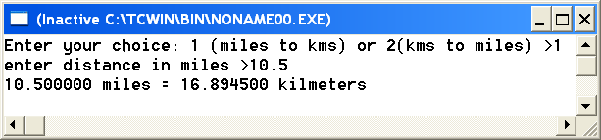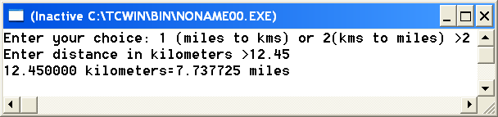
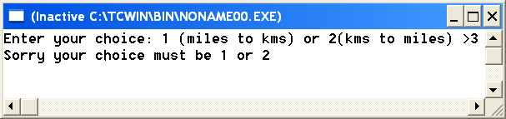
#include <stdio.h>
#define KMS_PER_MILE 1.609
int main() {
int choice;
double kms, miles;
printf("Enter your choice: 1 (miles to kms) or 2(kms to miles) >");
scanf("%d",&choice);
switch(choice){
case 1: printf("enter distance in miles >");
scanf("%lf",&miles);
kms=miles*KMS_PER_MILE;
printf("%f miles = %f kilmeters",miles,kms);
break;
case 2: printf("Enter distance in kilometers >");
scanf("%lf",&kms);
miles=kms/KMS_PER_MILE;
printf("%f kilometers=%f miles",kms,miles);
break;
default: printf("Sorry your choice must be 1 or 2");
}
return 0;
}
Question 9 (18 points)
Write a program that asks the user for a code character and a radius. The code character can be:
A or a to compute and display the area of the circle
C or c to compute and display the circumference of the circle
D or d to compute and display the diameter of the circle
$$\begin{aligned}\text{area}=π r^{2} \\ \text{circumference}=2π r \\ \text{diameter}=2r\end{aligned}$$
Use if-else-if statement

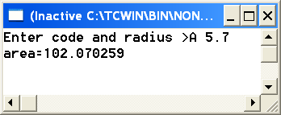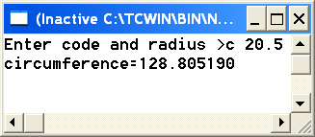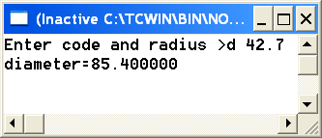
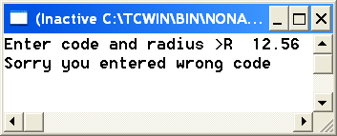
#include <stdio.h>
#define PI 3.14159
int main() {
double radius,diameter,area,circum;
char choice;
printf("Enter code and radius >");
scanf("%c%lf",&choice,&radius);
if(choice == 'A' || choice == 'a') {
area=PI*radius*radius;
printf("area=%f",area); }
else if(choice == 'C' || choice == 'c') {
circum=2*PI*radius;
printf("circumference=%f",circum); }
else if (choice=='D' || choice == 'd') {
diameter=2*radius;
printf("diameter=%f",diameter);
}
else
printf("Sorry you entered wrong code");
return 0;
}

